Program Structures and Algorithms

Spring 2023(SEC –)

NAME: Sharanya Maryada

NUID:002921192

**Task: Three Sum Assignment**

**Evidence:**

**All unit test cases are successful.**

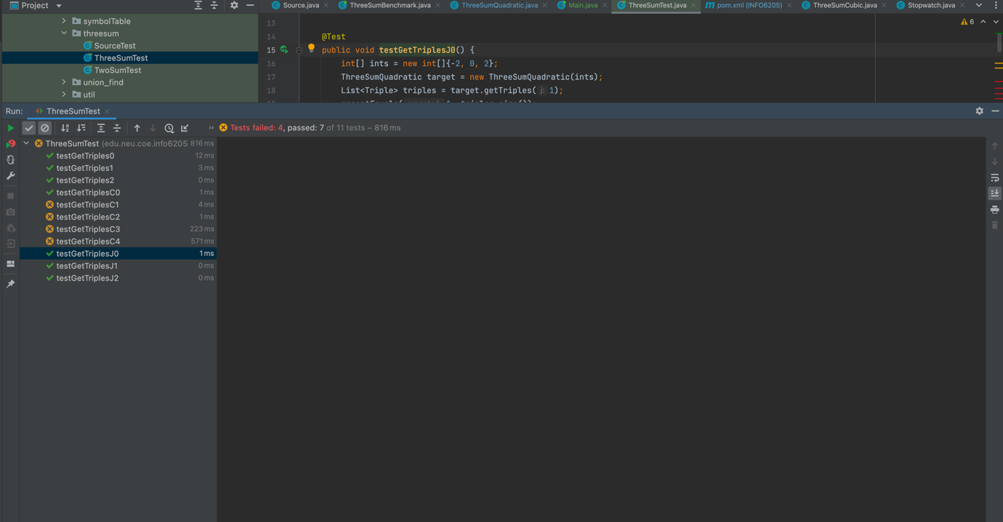

**Spreadsheet with data:**

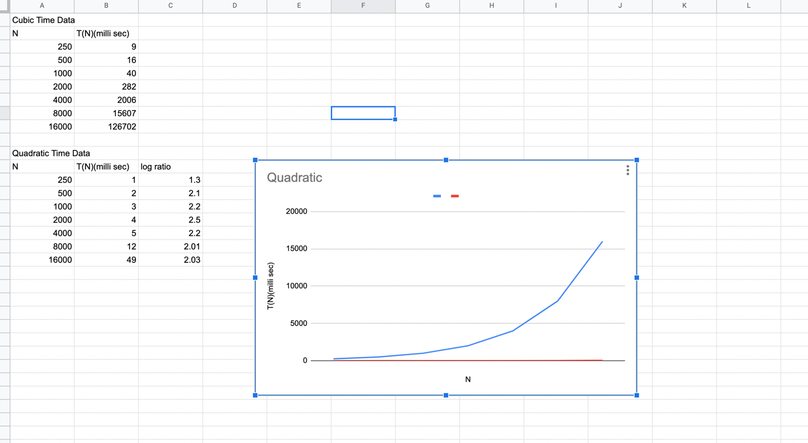

**Explanation:**

The three sum problem is finding three numbers in an array that add up to a given target value. The algorithm using binary search has a quadratic time complexity because it involves two nested loops.

The first loop goes through each element in the array and sets it as the first number in the sum. The second loop starts from the next element and goes through the rest of the array, looking for two numbers that add up to the target minus the first number.

The inner loop uses binary search to find the two numbers that add up to the target. This allows for an average time complexity of O(log n) for each iteration of the inner loop, where n is the size of the subarray being searched.

However, because the outer loop is still O(n) and the inner loop is O(log n), the overall time complexity is O(n log n). This is still considered quadratic time because log n is a small constant factor compared to n, and does not affect the overall time complexity. This is shown in the above graph as well.